

2021 West Coast North Island
OPEN Track Championship
30th January 2020
(Rain day January 31st)
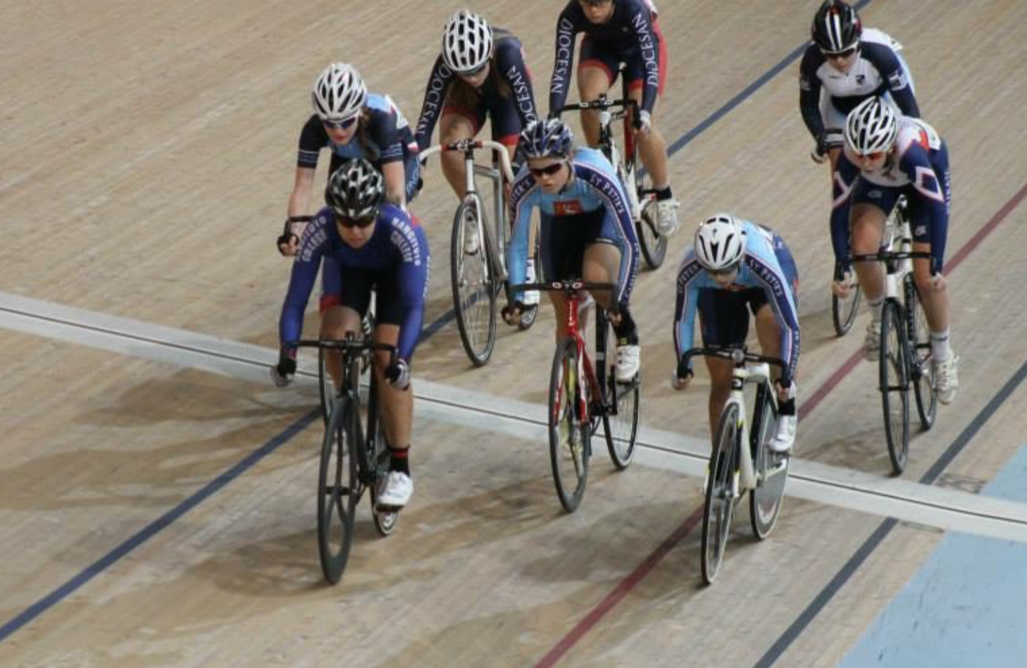

Welcome to the West Coast North Island Track Championship for 2017.
Racing Starts : 10-00am
Entries/Registration: 8:45 – 9-30
Rider Briefing: 9-45
Entries will be “on the day” but it would help if you could print the registration form at the back of this booklet, complete it and bring it with you on race Day.

Wanganui Velodrome
Sign on from 9:15 – 10:00AM
Track Open for warm-up Until 10:20AM
Racing starts 10:30AM

Commissaires
Chief Commissaire – tbc
Assistant Commissaire - tbc
Assistant Commissaire – tbc

Race Committee
- Event Manager Nick Spark
- Assistant Manager tbc
- Chief Judge tbc
- Chief Timekeeper tbc
- First Aid Steph Foote

WCNI OPEN TRACK CYCLING
CHAMPIONSHIPS
PROGRAM

Saturday 30th January 2021 - Racing Starts 10:30am
Event Grade
Masters 1 Men - 750m |  | Time Trial - FINAL
Masters Men (2) - 500m |  | Time Trial - FINAL
Under 13 Boys - 500m |  | Time Trial - FINAL
Under 13 Girls - 500m |  | Time Trial - FINAL
Under 15 Boys - 500m |  | Time Trial - FINAL
Under 15 Girls - 500m |  | Time Trial - FINAL
Under 17 Boys - 500m |  | Time Trial - FINAL
Under 17 Girls - 500m |  | Time Trial - FINAL
Open Women/Masters Women - 500m |  | Time Trial - FINAL
Open men - 1000m |  | Time Trial - FINAL
AWA - 1000m |  | Time Trial - FINAL
Masters Women |  | Pursuit 2000 Finals
Masters 1 Men |  | Pursuit 3000 Finals
Masters 2 Men |  | Pursuit 2000 Finals
Under 13 Boys & Girls 3 lap Derby
Under 15 Boys 3 lap Derby
Under 15 Girls 3 lap Derby
Under 17 Boys |  | Sprint Qualifying Round
Under 17 Girls |  | Sprint Qualifying Round
Open Women (U19+) |  | Sprint Qualifying Round
Open Men (U19+) |  | Sprint Qualifying Round
Lunch and Medal Presentation.
Under 17 Boys |  | Pursuit 2000 Finals
Under 17 Girls |  | Pursuit 2000 finals
U19 Women |  | Pursuit 2000 Finals
Elite Women |  | Pursuit 3000 Finals
Under 19 Men |  | Pursuit 3000 Finals
Elite Men |  | Pursuit 4000 Finals
AWD |  | Pursuit 3000 Finals
Under 15 Girls |  | 1500m Scratch Race
Under 15 Boys |  | 1500m Scratch Race
Under 17 Girls |  | Sprint Finals (best of 3 rides)
Under 17 Boys |  | Sprint Finals
Open Women (U19+) |  | Sprint Finals
Open Men (U19+) |  | Sprint finals
Under 15 Girls |  | 2000m Scratch Race
Under 15 Boys |  | 2000m Scratch Race
Open Women (U19+) |  | Keirins | (Heats of six)
Open Men (U19+) |  | Keirins | (Heats of six)
Team Sprints |  | (for all Centre teams hoping
 |  | to ride Nationals)
Keirin finals if required
Under 17 Boys |  | Scratch Race 3000m
Under 17 Girls |  | Scratch Race 3000m
Open Women (U19+) |  | Scratch Race 5000m
Open Men (U19+) |  | Scratch Race 6000m

Entry Fees.
U17 and younger $5-00 per event Number of events X $5-00 =
All other grades $6-00 per event Number of events X $6-00 =
Team events $6-00 per rider. Number of events X $6-00 =
Track Hire $12-00 per rider. $12-00
Total $
Payment can be made direct to WCNI Cycling Centre at Westpac 030718 0390677-00
Please quote your name in the Reference Field.

Notes
- Entries will be taken before the event. It is advised to enter and pay entry fees before the event. Any rider who enters on the day of the event, or where payment has not been received, by at the latest, the day prior to the event will incur a $10 surcharge. On the day registration will close 30 minutes prior to the start of racing.
- There will be no eftpos facilities at the velodrome so please pay in cash.
- All riders must wear their Club colours.
- All events are open to riders outside of the WCNI Centre with the exception of the individual Sprint Semi and Finals. (Selectors need to view only centre riders to evaluate seeding and team combinations).
- Sprint qualifying and Semi Finals will be a single race with the Finals to be best of 3 rides.
- Sprint finals may be ridden for non-centre riders if time permits.
- Derby races may be Heats then Final depending on numbers

Gearing and Equipment
U15 6.61m rollout no aero helmets no TT bars
U17 7.0m rollout aero helmets clip on TT bars
Open U19 open gears aero helmets TT bars
All other age groups - open gears

Timing
Timing will be done manually, so no need for transponders.

New Records or Record Attempts.
- If a record has been broken during the days riding an application form for formal recognition of this new time must be completed. Current records and Application Forms are available from the Event Manager.
- Any riders wanting to attempt a challenge to an existing WCNI record time must notify officials at the beginning of the day or as soon as practicable. These attempts will be run either in the lunch break or at the end of the days racing.
- Centre records can only he held current WCNI centre members.
Numbers
One centrally in the middle of the back, and the other on the left side readable when the rider is in the prone riding position. Numbers are to be returned to officials at the end of the days racing. Any numbers not returned will incur a cost of $20 invoiced to the riders Club.

Entries
- Entry is available to any rider affiliated to a Cycle Club.
- Entry prior to the event is advised. Any rider who enters on the day of the event OR who pays their entry fee on the day of the event will be charged a surcharge of $10.00.
- If a rider is scratched they must notify the organisers as soon as possible so start lists can be altered accordingly.
- By entering this event riders acknowledge that they agree to the following:

- I am aware of the dangers of track cycling/ racing and compete in the event at my own risk.

- I have read and understood any written race instructions and acknowledge that all instructions, whether written or verbal, are clear and unambiguous. Take careful note of the pre-race briefing given to you by the starter.

- The organisers have done their best to make the event as safe as they can.

- I must obey all the track rules.

- The decision of the Commissar is final and discussions will not be entered into.

- If I am involved in an accident, I will not seek to blame or make a claim against the organisers. Nor will I assist anyone else in making such a claim.

- If I have any concerns with the race organisation, I will raise them with the organiser first. I will not raise them with any other person, recognising that I will only jeopardise the continuation of the event.

Licences
Riders are to ensure they have a valid 2021 licence card with them or have it readily available at all times during the Event, or if it is still being processed, a receipt and a form of photographic identification available.
Note please:
From Cycling NZ Road & Track Technical Regulations:

Section A: General
LICENCES:
  - All members, competitors and Officials shall be licensed.
  - The following categories are available:
- ME Men’s Elite Riders 23 to 34 years of age
- WE Women’s Elite – Riders 19 to 34 years of age
- MU – Men’s Under 23 – Riders 19 to 22 years of age
- MJ & WJ – Junior Under 19 – Riders 17 to 18 years of age
- Junior Under 17 – Riders 15 to 16 years of age
- Junior Under 15 – Riders under 15 years of age
- Master 35 and over in 5 year age brackets (Masters 1 to Masters 8. MM1 = Men Masters 1, WM2 = Women’s Maters 2 etc) (for ROAD events).
- Masters Track Category 1 – Riders 35 to 44 years of age
- Masters Track Category 2 – Riders 45 to 54 years of age
- Masters Track Category 3 – Riders 55 and over
- Official / Technical – for team & club officials and handlers who are not otherwise licenced under 1a to i inclusive.
- Commissaire

Equipment
- Bicycles must confirm with current UCI regulations.
- Helmets must be compliant with the NZ Transport Agency Standards.
Rules.
- Racing will be conducted under UCI regulations and Cycling NZ Technical Regulations. A copy of these regulations will be available for perusal on race day or visit the Cycling NZ web site.
- Helmets must be worn at any time a rider is on their bike.
Riders Apparel
Riders must only wear their approved Club jerseys and shorts. Shorts may only display sponsors that are detailed on the riders racing licence.
Medals and Medal Ceremony.
- Medals are awarded on the following basis.
  - In any category, 1 rider-1 medal, 2 riders - 2 medals, 3 riders-3 medals, irrespective of what centre the rider represents.
  - Records can only be held/awarded to WCNI Club members.
- All riders shall participate in official ceremonies.
- All riders must wear their official club colours on the podium.
- No sunglasses or caps etc to be worn on the podium.
- Medal winners are to wear their medal around their neck until they have exited the podium area.

